Full Robocode setup + Intellij setup instructions

Table of Contents

Install Robocode 1

Setup Development With Intellij 6

Create New Project 6

Setup Robocode Libraries 7

Create Package + Robot file 11

Point Robocode to your Robot files 12

Setup Intellij Debugging 14

Tournament Rules 17

Robocode Rules 17

Scoring 18

Tournament bracket 19

Useful links 19

# Install Robocode

* Make sure you have java setup on your computer <https://robowiki.net/wiki/Robocode/System_Requirements>
  + Most people can skip this step, as Vault uses Java
* Download latest release JAR at https://sourceforge.net/projects/robocode/files/robocode/1.9.5.1/
  + Consider uploading this to a google drive?
* Run the downloaded jar "robocode-1.9.5.1-setup.jar"
  + You may see an error like, just run it anyways, its open source.
    - 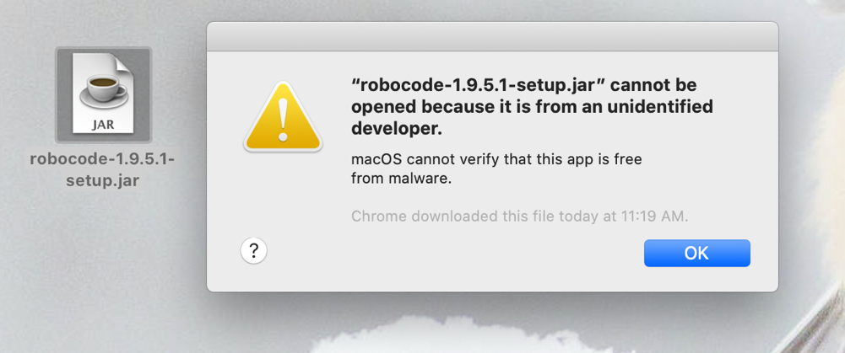
  + On mac you can get around this by control clicking the jar file, and hitting open
    - 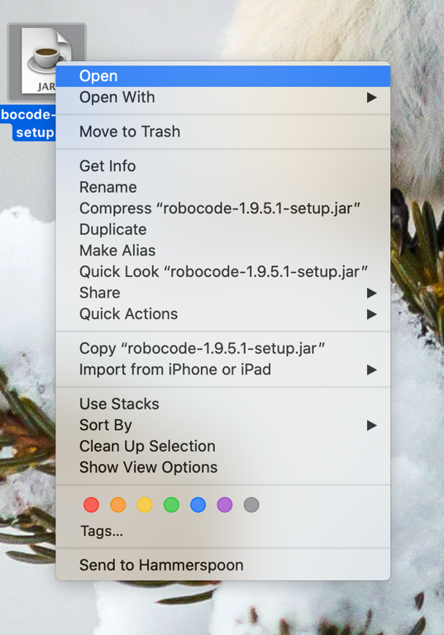
  + TODO: Test + Add workaround for windows
* Follow instructions to setup:
  + Select NO if you want a different setup path.
    - 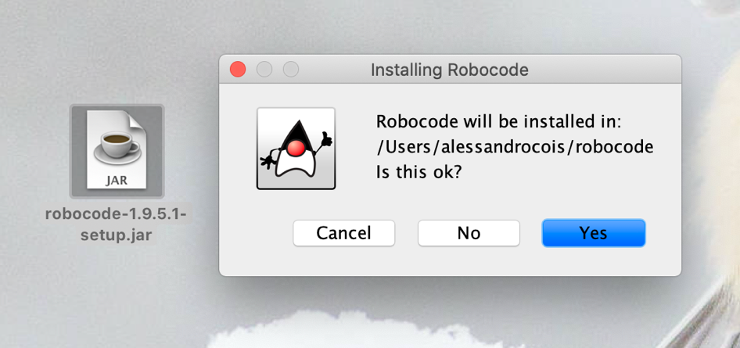
    - 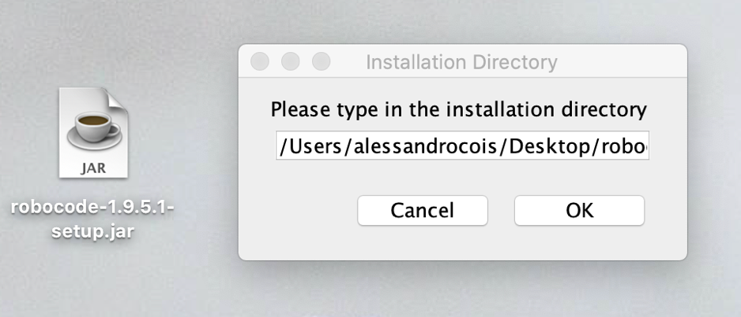
  + Follow the rest of the instructions, you should see success at the end if all went well.
    - 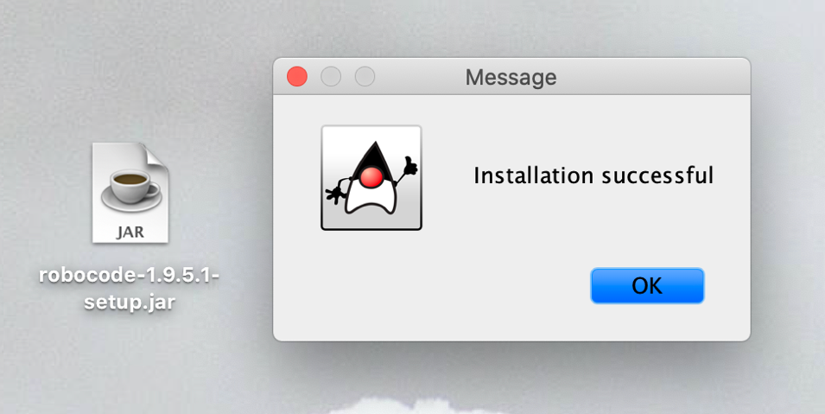
* Run robocode, by double clicking “robocode.sh” (not the other sh files)
  + - 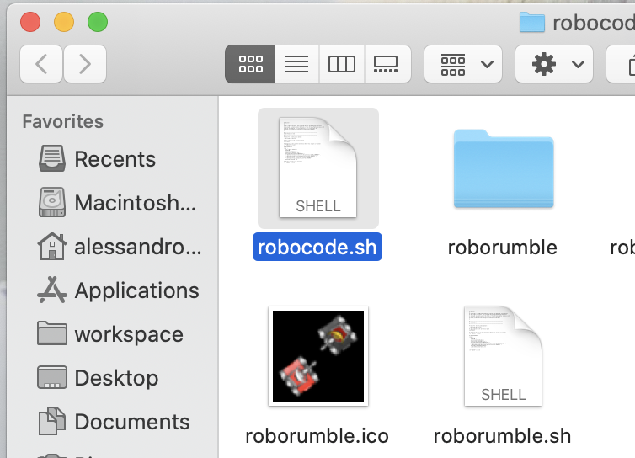
  + Alternatively, if that doesn’t work, you can run it from the terminal
    - 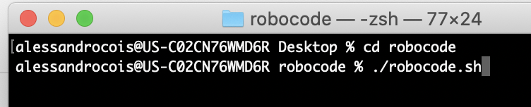
* You should see a splash screen, then the application pop up!
  + It may run a battle or just show the title.
  + A screenshot of a computer

    Description automatically generated
* Run your first battle
  + Select Battle from the top menu, and click “New
    - 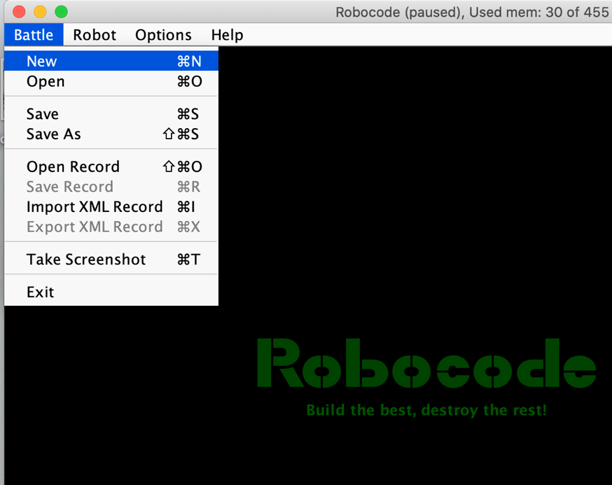
  + Add a few sample robots to your battle, then click start battle at the bottom!
    - A screenshot of a computer

      Description automatically generated
  + A battle should pop up and play out! Yay!
    - 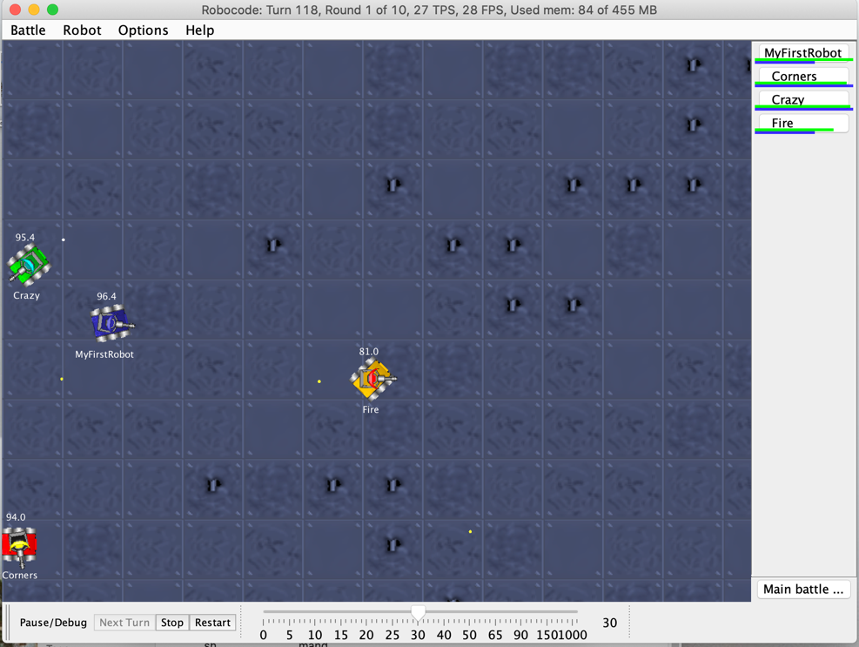

# Setup Development With Intellij

* If you do not care about debugging, autocomplete or your intellij hotkeys, you can use the built in editor. See instructions here <https://robowiki.net/wiki/Robocode/My_First_Robot>

## Create New Project

* Setting up your Intellij environment.
  + Create a new intellij project
    - 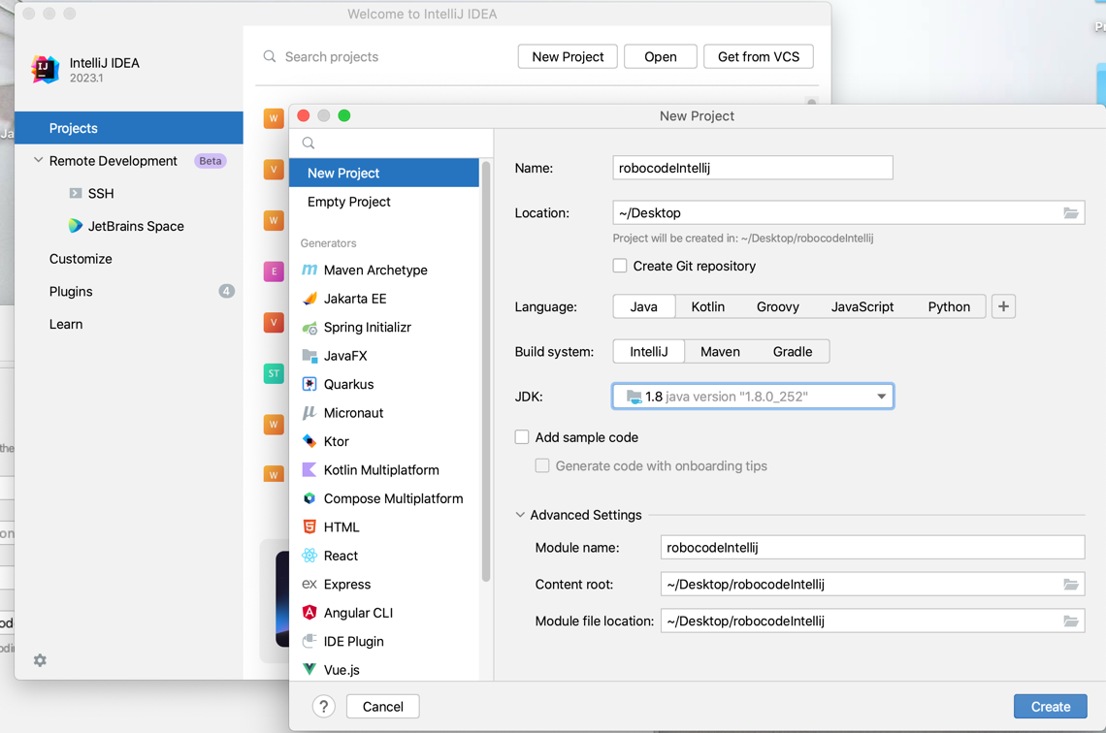

## Setup Robocode Libraries

* + Open module settings for your top folder
    - A screenshot of a computer

      Description automatically generated
  + Go to the libraries section, and add a “Java” library
    - A screenshot of a computer

      Description automatically generated
  + Add both the “Javadoc” and “libs” folder
    - A screenshot of a computer

      Description automatically generated
  + Your “Libraries” should look like this. (Don’t worry about Name).
    - A screenshot of a computer

      Description automatically generated
  + Your “Modules” should look like this
    - 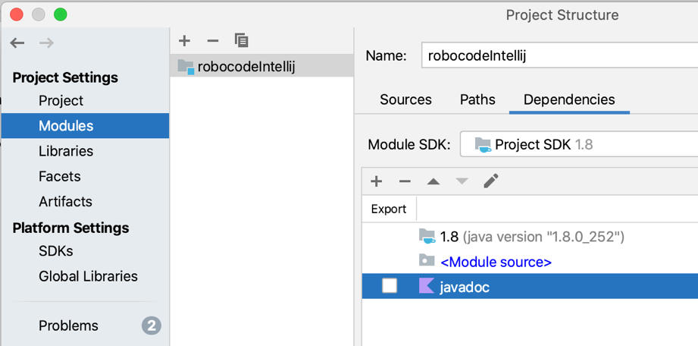
  + Click Apply + Okay at the bottom.

## Create Package + Robot file

* Create a new package under src named “gvconnect”
  + A screenshot of a computer

    Description automatically generated
* Create a java file/class named “team#_TeamBotName”inside of “gvconnect” package.
  + Import robocode.Robot
  + Extend Robot (or Advanced Robot if you are spicy)
  + You should start seeing auto complete!
  + 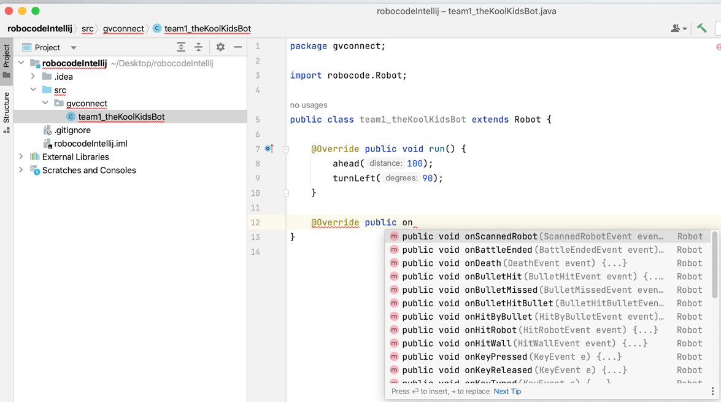
* Setup a simple robot and verify you can build. It should go to an “out” folder.
  + - 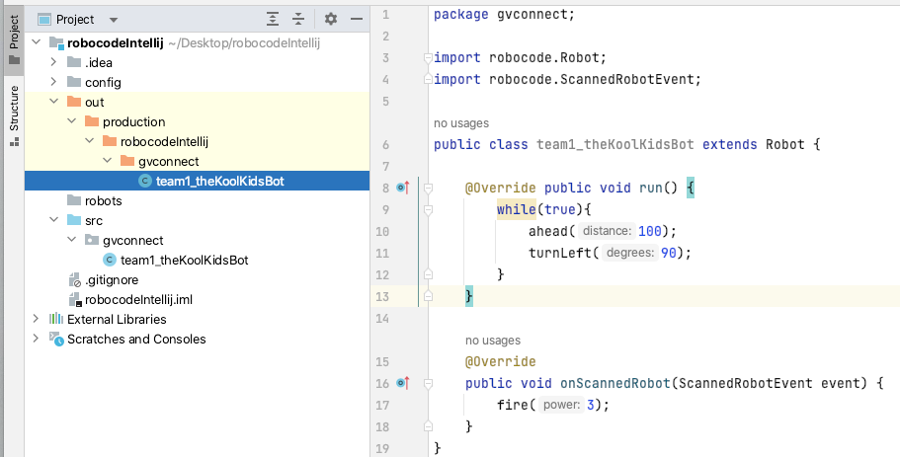

## Point Robocode to your Robot files

* + Go to options > preferences in the menu
    - 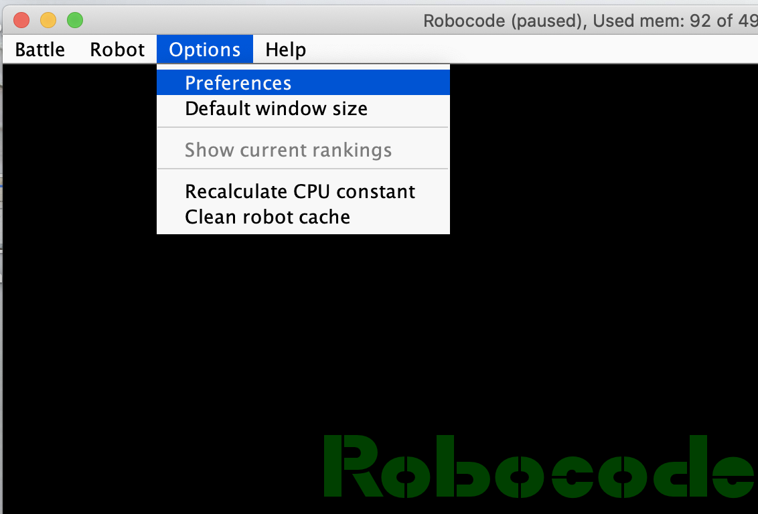
  + In development options add path to “projectName/out/production/projectName”
    - THIS IS VERY IMPORTANT TO GET EXACT PATH.
    - A screenshot of a computer

      Description automatically generated
  + Hit finish and go create a new battle. After hitting Cmd + R, you should see your new bot! You can add it and battle with it.
  + A screenshot of a computer

    Description automatically generated
* You can now develop and test your robot.

# Setup Intellij Debugging

* Edit your run configurations
  + - A screenshot of a computer

      Description automatically generated
* Add an application configuration
  + - A screenshot of a computer

      Description automatically generated
* Add VM options to your configuration.
  + - 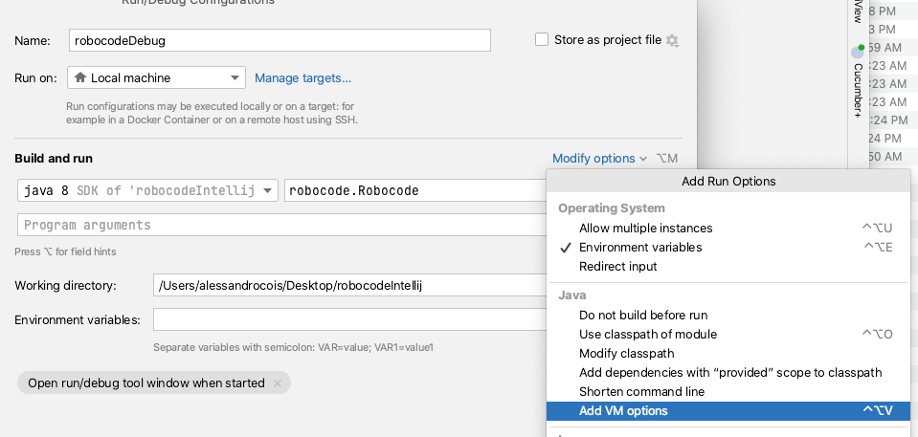
* Make your run configuration look like this:
  + VM options: -Xmx512M -Dsun.io.useCanonCaches=false -Ddebug=true
  + Main class: robocode.Robocode
  + Working directory: path/where/you/installed/robocode
    - 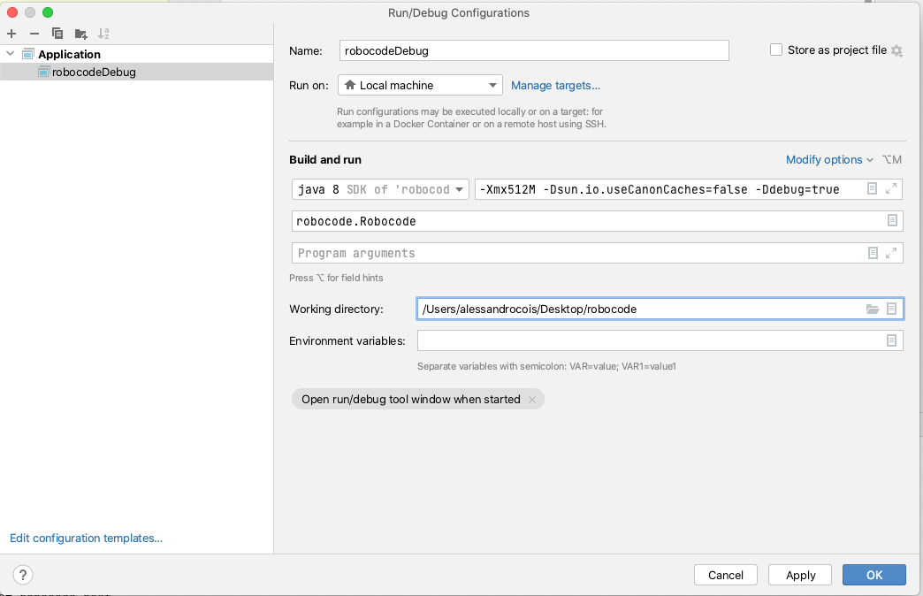
* Now hit debug in intellij with some breakpoints and start a battle with your bot!
  + A screenshot of a computer

    Description automatically generated
* When the battle runs, and your bot code runs, it will stop and you can debug!
  + 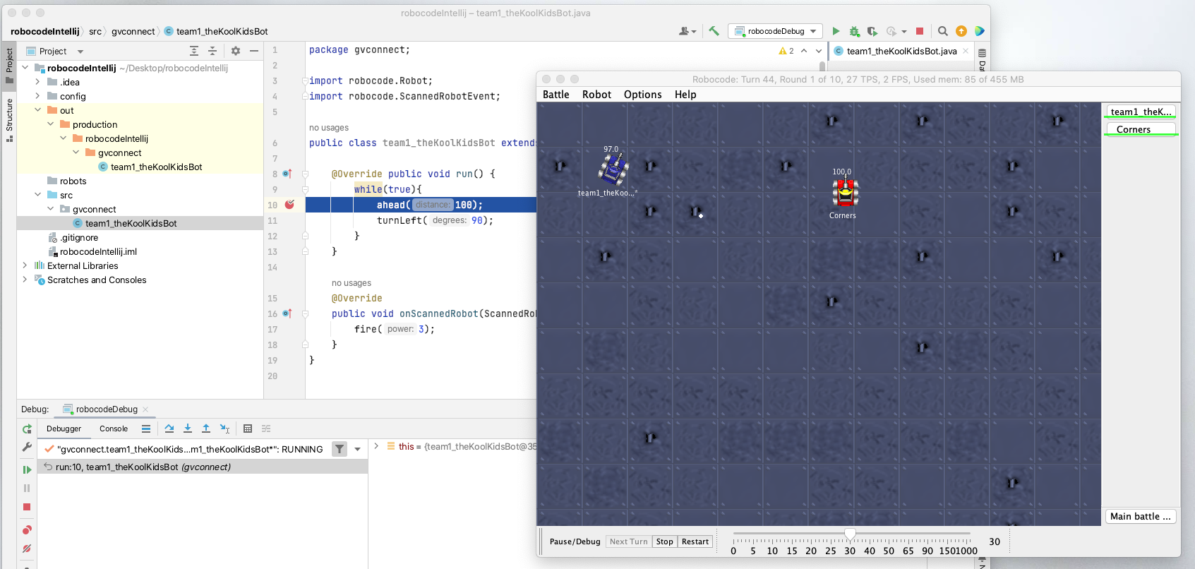

# Tournament Rules

## Robocode Rules

We will be having a melee tournament. Meaning bots will fight on a 1000x1000 grid, with 10 bots total on the screen.

<https://robowiki.net/wiki/Melee>

When creating a new battle, hit the rules tab at the top, set your board to 1000x1000 so you can test your bots in the correct space!

You also may want to set number of rounds to 1 for testing.

Leave the other rules as default.

Your robot may only extend “Robot” or “AdvancedRobot”.

Do not implement “BorderSentry” or “Droid”.

## Scoring

Scoring will be based on the “Total Score” at the end of the rounds. This can be seen in a pop-up once all rounds are over.

<https://robowiki.net/wiki/Robocode/Scoring>

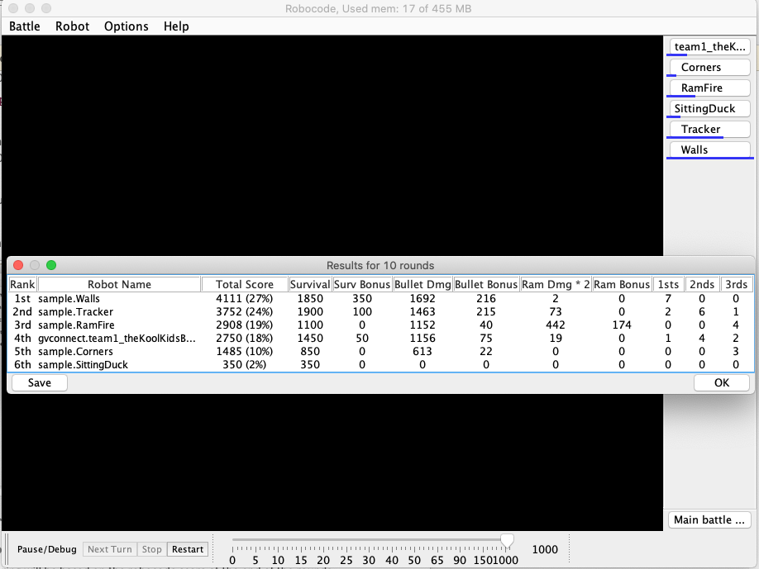

## Tournament bracket

There are 60 teams. 10 robots will fight at a time. There will be 6 winners in the first round.

Then we will fight those 6 winners against each other to decide our champion.

# Useful links

Start with -> Wiki FAQ - <https://robowiki.net/wiki/Robocode/FAQ>

API - <https://robocode.sourceforge.io/docs/robocode/>

Melee Strategy - <https://robowiki.net/wiki/Melee_Strategy>

Wiki home page - <https://robowiki.net/wiki/Main_Page>